Team 5

REAL TIME PAYMENT SYSTEM

Design Document

Table of Contents

Executive summary 2

Gathering payment information 2

Sending payment orders 3

Instant payment network 8

Conclusion 10

References 11

# Executive summary

In this report, we will discuss our design of the real time payment (RTP) system for Wal-Mart. For Wal-Mart, it wants to use the RTP to reach two main purposes. The first is the ability to pay its employee on their demands in order to ease employees’ economic burden. The second is to pay its 60,000 suppliers immediately after the goods are received to take advantage of early-pay discounts offered by suppliers and thus, lower the cost for Wal-Mart. To realize Wal-Mart’s need for the RTP system, we design a system that can send instant payment to employees and suppliers within several minutes. In this report, we will introduce our RTP system design from three parts: how to gather the payment information, how to send the payment orders to banks and how our instant payment network works.

# Gathering payment information

In this section, we will discuss how our system gathers payment information from Wal-Mart’s HR and ERP system as the basis to form the payment orders send to banks.

For instant payments to employees, our system will have a mobile app on employee’s side. When an employee requests an immediate payment for their salary, this request will be send to Wal-Mart’s HR system with the unique employee ID, amount of salary request and expected date of payment. In Wal-Mart’s HR system, there is a meta database containing each employee’s salary, personal information, payment history and payment method (including each employee’s bank account information). Our system will first verify the employee’s request and if the request is valid (i.e. sending from the employee’s registered device and the salary amount requested is correct), our system will then generate a payment order from the HR system containing the employee’s name, bank account information, payment amount details to the bank for instant processing. The details of how the payment order will be structured and how it will be sent to the bank will be discussed in the next section.

For instant payments to suppliers, our system will integrate with Wal-Mart’s current ERP system: SAP. Currently in Wal-Mart, it will generate a unique purchase order for every good it purchases from its suppliers and when Wal-Mart receives the goods, it will have the unique ship & invoice number from its suppliers. The unique purchase order and the invoices are the identifier for each purchase from the suppliers. The payment process is triggered with Wal-Mart’s receiving department scans the goods to indicate we have received the correct goods from our suppliers. Then, in Wal-Mart’s current ERP system, the goods will be shown as received and have the unique purchase orders and invoices assigned for the goods. Our system will use the unique purchase order and invoice number to look up in the SAP system for the payment amount and the registered bank account information of the suppliers. Finally, these payment details will be presented in the payment orders send to the bank and structured in the format discussed in the next section. It is important to note that our system will be automatically triggered and there are no manual operations necessary once the goods are scanned and indicated as received by Wal-Mart.

# Sending payment orders

In this section, we will discuss how our system sends the payment order to Wal-Mart’s bank for instant processing and how our payment orders will be structured. We decide to use ISO20022 as the accepted messaging standard. ISO20022 is an ISO standard for electronic data interchange between financial institutions. It describes a metadata repository containing descriptions of messages and business processes, and a maintenance process for the repository content. The standard covers financial information transferred between financial institutions that includes payment transactions, securities trading and settlement information, credit and debit card transactions and other financial information.

The repository contains a huge amount of financial services metadata that has been shared and standardized across the industry. The metadata is stored in UML models with a special ISO 20022 UML Profile. Underlying all of this is the ISO 20022 meta-model - a model of the models. The UML profile is the meta-model transformed into UML. The metadata is transformed into the syntax of messages used in financial networks. The first syntax supported for messages was XML Schema.

There are several benefits that ISO20022 can provides and for these reasons, we choose to use the ISO20022 standards. Firstly, ISO20022 offers flexibility for the real-time payments. ISO20022 has rich set of data definitions, flexible character lengths and types to support rich payment information. Thus, using ISO20022 enables us to flexibly include more information and indicate the payment type is instant payment to distinguish from the regular ACH payment arrangements. Also, ISO20022 is supported by sophisticated toolsets and utilities to manage them that greatly simplify definition of new message sets and rule. So, it is its data richness, flexibility and maintainability that make ISO20022 the better standard for real-time payment systems. Besides, the ISO20022 gives users the ability to harmonize formats that did not previously allow for cross-operation, which improves efficiency while reducing costs and exposure to risk. And It improves the quality of data exchanged between financial institutions by introducing structure and consistency to the data dictionary.

In our system, we design a ISO20022 auto client, which is directly linked to both the ISO20022 network and Wal-Mart’s system. It serves as the link between Wal-Mart and ISO20022 network and mainly has to functions. Firstly, it will transform each payment requests of Wal-Mart to ISO20022 format. Secondly, it will communicate this payment order to the banks using the ISO20022 network.

The ISO20022 message format sample are shown as below. It should contain several key components. They are account information, party information, postal address, agent, amount, remittance information and bank transaction code. For the customer credit transfer initiation, the structure is divided by Group Header and Payment Type Information. The Group Header contains the basic information of the transaction, especially it will include a line to indicate the concerned payment is an instant payment so that the banks will process them accordingly. The Payment Type Information contains the detail information of the debtor agents, debtors, creditor agents and creditor.

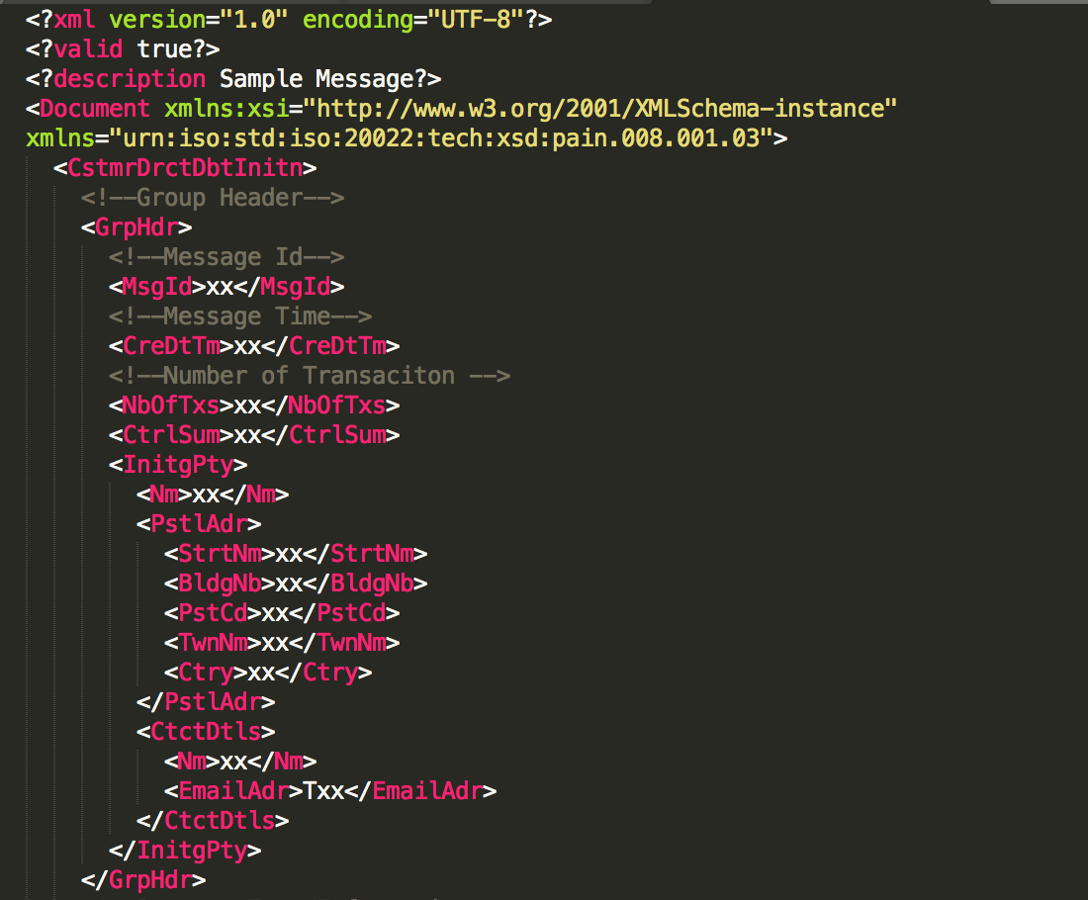

**Group Header**

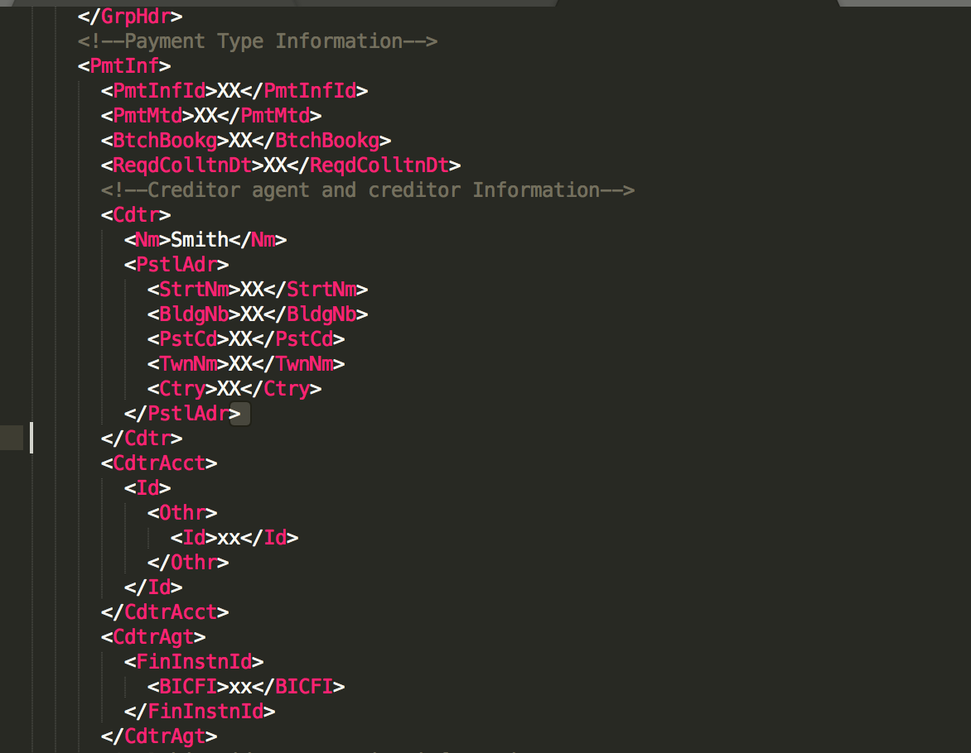

**Creditor Agent and Creditor Information**

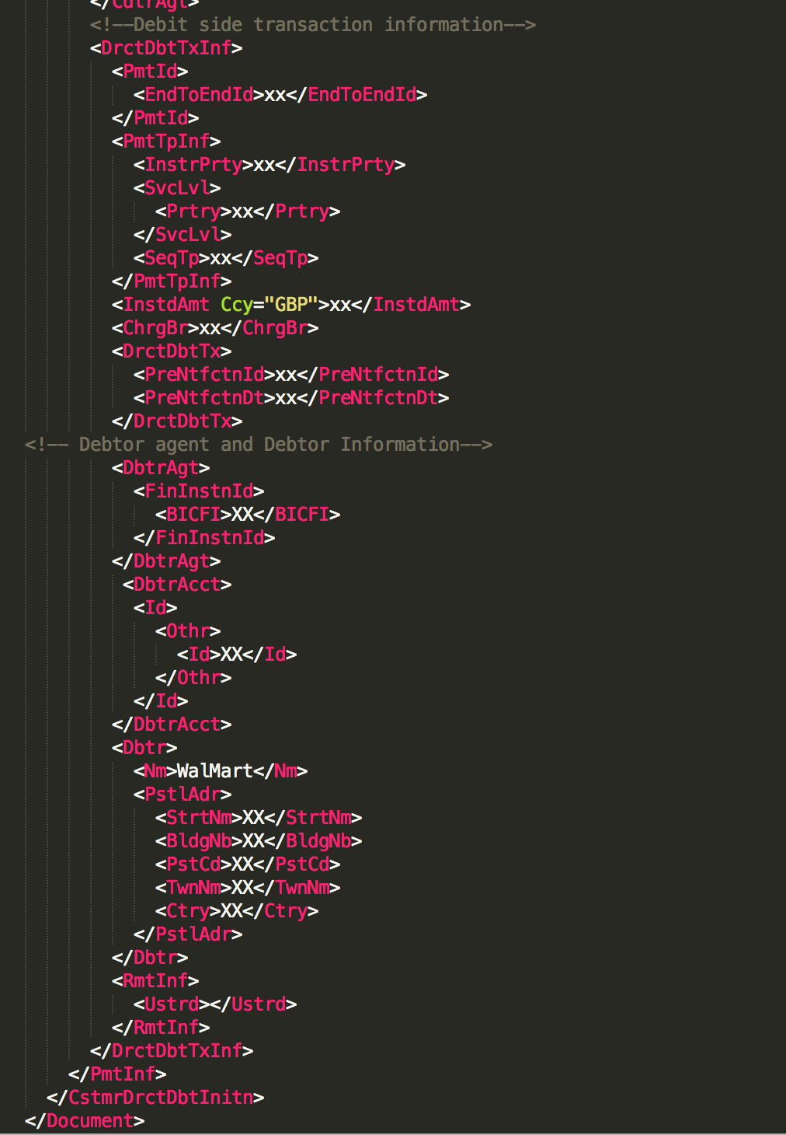

**Debtor Agent and Debtor Information**

Next, we will discuss the message flow (the flow of the ISO20022 payment orders) in our system. The picture below shows the basics of the information flow.

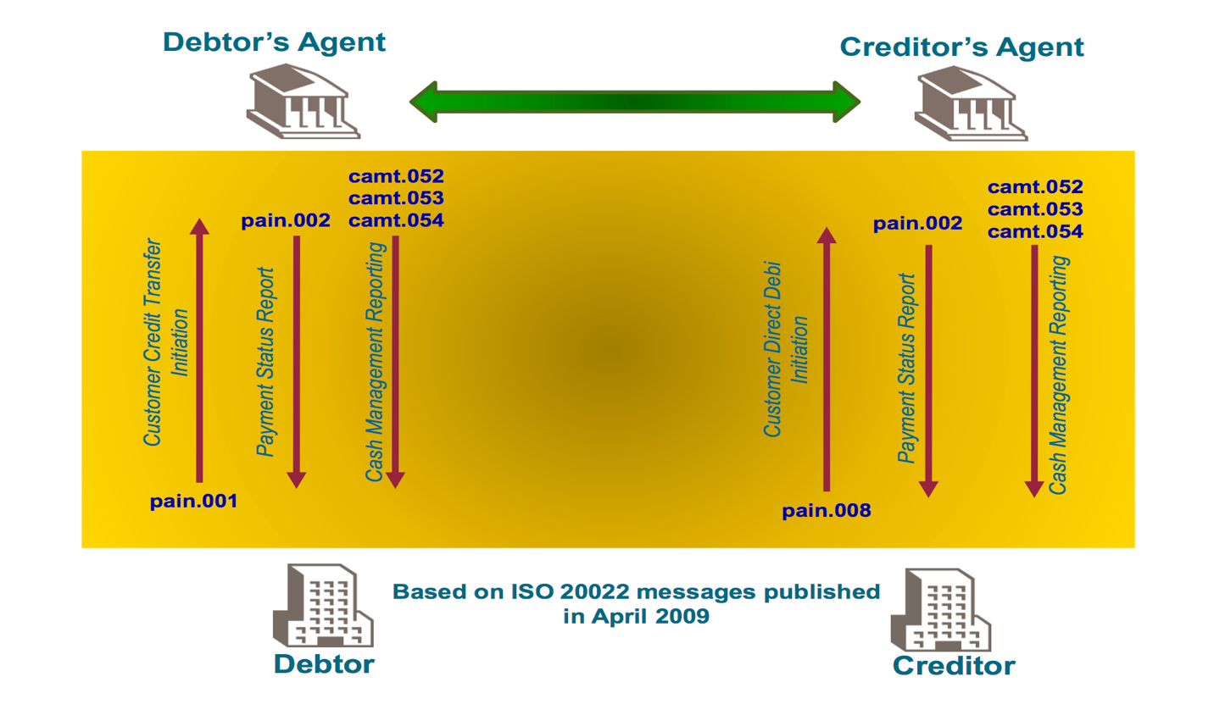

When Wal-Mart employees request their salary at any time, Wal-Mart initiates ISO20022 messages containing the payment orders to the Wal-Mart’s banks. The payment order is used to request payment from Wal-Mart’s accounts. After Wal-Mart’s banks received the payment order, a payment status report is created and send to Wal-Mart. At the same time, the payment order will be transferred to the employee’s bank for execution. A payment status report will be send to the employees as soon as possible after receipt of the payment order by the employee’s banks. Finally, employees will receive the payment as instructed on the payment orders. The payment status report reflects the status after validation on input day and may contain either rejected instructions or both accepted and rejected instructions. Rejected instructions are not booked or processed.

When Wal-Mart receives their goods from suppliers, Wal-Mart also initiates ISO20022 messages containing the payment orders to the Wal-Mart’s banks through the ISO20022 network. When the payments are received properly and encrypted signature(s) are verified, the payment request is accepted, and Payment Status Report is created for Wal-Mart. When the Payment Status Report has reached the Wal-Mart, it implies that the bank acknowledges receipt of the message and assumes responsibility for further processing of the transactions. The payment orders will then be processed (converted to domestic or international formats) and transmitted to the supplier’s banks for execution.

# Instant payment network

In this section, we recommend Swift GPI as a solution for Wal-Mart when paying its employees on their demand and also paying its 60,000 suppliers when goods are received. Swift GPI guarantees the fast, transparent and secure delivery of hundreds of billions of dollars in payments among participants around the world.

In our case, when Wal-Mart wants to pay immediately to its employees and suppliers, there are three parties involved:

1. Bank A (Bank of Wal-Mart)

2. An Intermediary

3. Bank B (bank of Employee/Supplier)

In the traditional method, the payment will start at Bank A, and accordingly move to an intermediary and finally Bank B as the destination.

There are several challenges involves in the traditional flow of payment:

1. The speed of payment movement cannot be ensured, which is a top concern of Wal-Mart. Neither the suppliers/employees nor the Wal-Mart can predict when the payment will arrive at the destination

2. Wal-Mart initiates payment through bank A, but the subsequent payment flow cannot be visibly tracked once it arrives at bank B.

3. The payment flow often involves fee issues. Conventionally, participant banks directly deduce the processing fees from the original transaction amount, thus it is a problem that Wal-Mart and supplier possibly cannot reach mutual agreement on the received and invoiced amounts.

To solve the above problems and most importantly, to ensure an instant payment, we recommend using SWIFT GPI service package: including Tracker, Directory, Observer, and Services, to enable Wal-Mart to become more efficient in transaction payments. The package will improve the payment experience by ensuring the following:

**A. Speed and Instant Payment**

Swift GPI provides a trust network among participant banks. With such ecosystem, Wal-Mart’s bank trusts the supplier’s bank to pay at the end of the day, if the funds received before the bank’s cut-off time. And the supplier’s bank is willing to credit the receiver immediately. SWIFT has been actively working with payment market infrastructures to ensures that local clearing and settlement are followed up after each payment.

According to SWIFT statistics, “50% of SWIFT GPI payments are credited in less than 30 minutes,” and payments could even “be credited to end beneficiaries within minutes - many within seconds.” With such instant payment, bank’s customers like Wal-Mart are facing shorter supply cycles and able to ship goods faster.

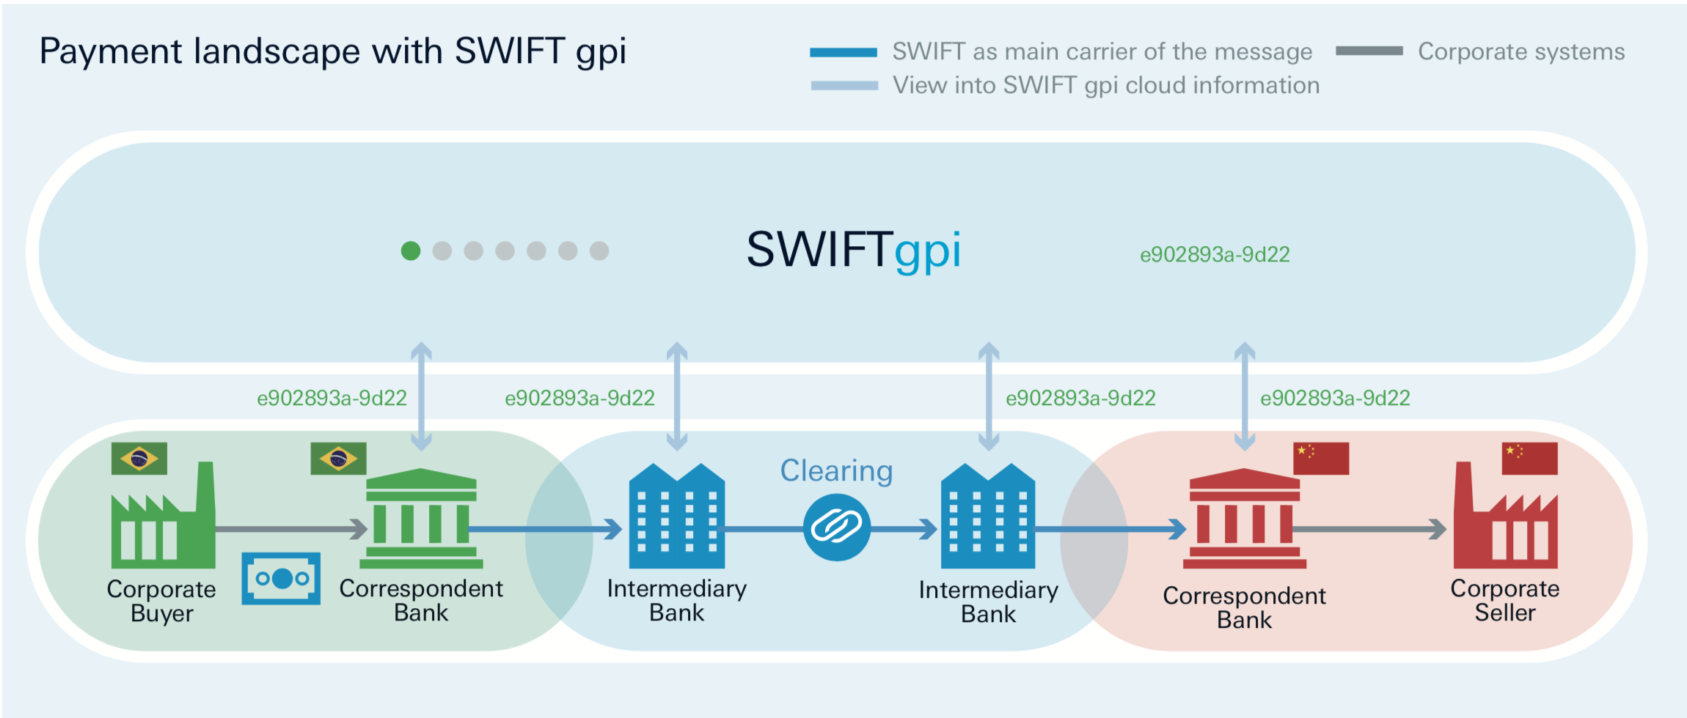

**B. No limitations on funds send and received**

Providing the fact that sufficient cleared funds are available to cover transaction and fees, there is no minimum or maximum transfer limit in SWIFT GPI. This is important for Wal-Mart, the top retail cooperation in the U.S even in the world, for each of its transaction with suppliers could involve a large number of funds. While using other digital payment networks like Zelle, the payer may be subject to the limitation of the money to send, which will cause inconvenience.

**C. Traceability**

To manage the transactions, SWIFT built up a Tracker database to keep track of the status of each payment transaction. The information is updated upon every step of the transaction movements, and thus could always provide Wal-Mart the real-time data about the payment flow.

From a technical perspective, the tracking functionality will be supported by a unique end-to-end transaction reference (UETR), which serves as a UUID in the Tracker database. Staring with the initiation of the payment in Wal-Mart’s bank, a UETR number is added to the payment. This unique number is sent along the flow with the payment until reaching the final destination of the supplier’s account. One the one hand, UETR allows Wal-Mart to track the payment like the tracking number used for a parcel. On the other hand, UETR means that each party in the payment link list will be able to confirm their position, making it possible for others in the chain to identify where the payment is in the lifecycle.

**D. Transparency**

The observer is the central service to ensures the transparency along the payment flow. It is created by SWIFT to monitor adherence to SLAs (service-level agreement) for all members. SLA is a commitment between a service provider and a client to ensure that particular aspects of the service – quality, availability, responsibilities – are agreed between the service provider and the service user.

The SLA demands the following:

• End-to-end same day processing of payments

• Transfer of full original amount (OUR payments)

• Transparency of fees (BEN/SHA payments)

• Transparency of FX rate

• End-to-end tracking of payments

• Transfer of payment information (remittance details F70).

With all the participants work collaboratively working towards a better implementation of the SLA, the whole system becomes transparent and more efficient. And such a transparent is also a good choice for Wal-Mart in the long run.

# Conclusion

In conclusion, our RTP system gathers payment information from Wal-Mart’s HR and SAP ERP system. Then, our system uses the ISO20022 standards to organize payment orders and send the payment orders to Wal-Mart’s banks using the ISO20022. Finally, our system utilizes the existing Swift GPI instant payment network to realize instant payment to employees and suppliers. We believe our design for Wal-Mart’s RTP system will help Wal-Mart to improve employee satisfaction rate and help to reduce Wal-Mart’s costs by making use of the early-pay discount from its suppliers.

# References

<https://en.wikipedia.org/wiki/ISO_20022>

<https://bankingblog.accenture.com/iso20022-is-the-standard-for-real-time-payments-thats-settled?lang=en_US>

<https://www.iso20022.org/sites/default/files/documents/Communications_Marketing_Resources/Resources_Understanding_ISO20022_NACHA_Payments_2013.pdf>

https://www.swift.com/news-events/press-releases/swift-gpi-reduces-cross-border-payment-times-to-minutes_even-seconds

<https://www.swift.com/news-events/news/swift-introduces-universal-real-time-payment-tracking>